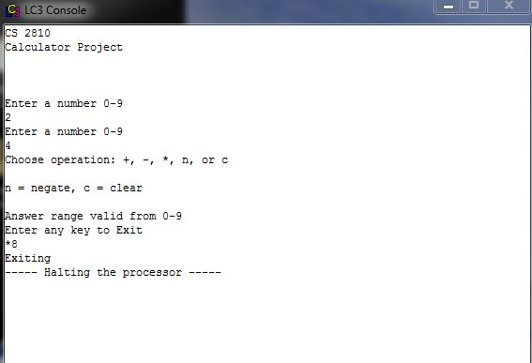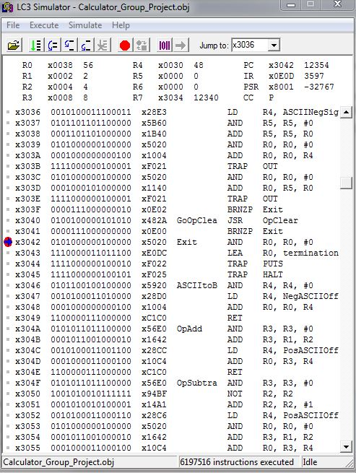

Screenshots of the LC-3 simulator and console windows of our calculator performing the multiply operation.

Take note of the following registers:

R0 contains the ASCII value of 8

R1 contains the first operand 2

R2 contains the second operand 4

R3 contains the product 8

R4 contains the offset value to convert the binary number into its ASCII equivalent